COA ASSIGNMENT No. 6
Aaditya Yuvaraj Hande
Div/Batch: A/A1
Roll No: 17
PRN: 202401040028

Result:
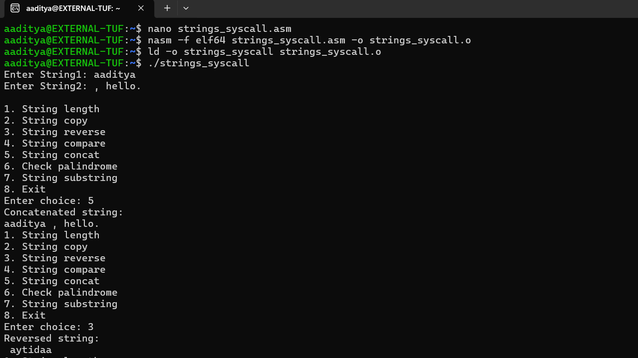
Code:
; SIMPLE STRING MENU USING SYSCALLS ONLY
; read = syscall 0
; write = syscall 1

%macro read 2
mov rax, 0
mov rdi, 0
mov rsi, %1
mov rdx, %2
syscall
%endmacro

%macro write 2
mov rax, 1
mov rdi, 1
mov rsi, %1
mov rdx, %2
syscall
%endmacro

section .data
menu db 10,"1. String length",10,\
"2. String copy",10,\
"3. String reverse",10,\
"4. String compare",10,\
"5. String concat",10,\
"6. Check palindrome",10,\
"7. String substring",10,\
"8. Exit",10,\
"Enter choice: ",0
menulen equ $-menu

msg1 db "Enter String1: ",0
len1msg equ $-msg1

msg2 db "Enter String2: ",0
len2msg equ $-msg2

msg_len db "Length = ",0
msg_len_len equ $-msg_len

msg_copy db "Copied string: ",10,0
msg_copy_len equ $-msg_copy

msg_rev db "Reversed string: ",10,0
msg_rev_len equ $-msg_rev

msg_eq db "Strings are equal",10,0
msg_eq_len equ $-msg_eq

msg_neq db "Strings are not equal",10,0
msg_neq_len equ $-msg_neq

msg_cat db "Concatenated string: ",10,0
msg_cat_len equ $-msg_cat

msg_pal db "Palindrome",10,0
msg_pal_len equ $-msg_pal

msg_notpal db "Not palindrome",10,0
msg_notpal_len equ $-msg_notpal

msg_sub db "Substring found",10,0
msg_sub_len equ $-msg_sub

msg_notsub db "Not a substring",10,0
msg_notsub_len equ $-msg_notsub

nl db 10

section .bss
str1 resb 100
str2 resb 100
str3 resb 200
choice resb 2
l1 resq 1
l2 resq 1
tmp_buf resb 32 ; <-- ADDED: buffer used by print_number

section .text
global _start
_start:

; ---------------------------------------
; GET STRING 1
; ---------------------------------------
write msg1, len1msg
read str1, 100
; rax = bytes read (may include newline), store length-1
dec rax
mov [l1], rax

; ---------------------------------------
; GET STRING 2
; ---------------------------------------
write msg2, len2msg
read str2, 100
dec rax
mov [l2], rax

menu_loop:
write menu, menulen
read choice, 2

mov al, [choice]

cmp al, '1'
je do_len
cmp al, '2'
je do_copy
cmp al, '3'
je do_reverse
cmp al, '4'
je do_compare
cmp al, '5'
je do_concat
cmp al, '6'
je do_palindrome
cmp al, '7'
je do_substring
cmp al, '8'
je exit_prog
jmp menu_loop

; ---------------------------------------
; 1. STRING LENGTH
; ---------------------------------------
do_len:
write msg_len, msg_len_len
mov rbx, [l1]
call print_number
write nl,1
jmp menu_loop

; ---------------------------------------
; 2. STRING COPY
; ---------------------------------------
do_copy:
mov rcx, [l1]
lea rsi, [str1]
lea rdi, [str3]
rep movsb

write msg_copy, msg_copy_len
write str3, [l1]
jmp menu_loop

; ---------------------------------------
; 3. STRING REVERSE
; ---------------------------------------
do_reverse:
mov rcx, [l1]
lea rsi, [str1]
lea rdi, [str3]

mov rdx, rcx
dec rdx
add rsi, rdx ; rsi -> last char

rev_loop:
mov al, [rsi]
mov [rdi], al
dec rsi
inc rdi
dec rcx
jnz rev_loop

write msg_rev, msg_rev_len
write str3, [l1]
jmp menu_loop

; ---------------------------------------
; 4. STRING COMPARE
; ---------------------------------------
do_compare:
mov rcx, [l1]
mov rdx, [l2]
cmp rcx, rdx
jne not_equal

lea rsi, [str1]
lea rdi, [str2]
repe cmpsb
jne not_equal

write msg_eq, msg_eq_len
jmp menu_loop

not_equal:
write msg_neq, msg_neq_len
jmp menu_loop

; ---------------------------------------
; 5. CONCAT
; ---------------------------------------
do_concat:
; copy str1
mov rcx, [l1]
lea rsi, [str1]
lea rdi, [str3]
rep movsb

; copy str2
mov rcx, [l2]
lea rsi, [str2]
rep movsb

mov rbx, [l1]
add rbx, [l2]

write msg_cat, msg_cat_len
write str3, rbx
jmp menu_loop

; ---------------------------------------
; 6. PALINDROME
; ---------------------------------------
do_palindrome:
mov rcx, [l1]
lea rsi, [str1]
lea rdi, [str1]

mov rdx, rcx
dec rdx
add rdi, rdx

pal_loop:
mov al, [rsi]
mov bl, [rdi]
cmp al, bl
jne not_pal

inc rsi
dec rdi
dec rcx
jnz pal_loop

write msg_pal, msg_pal_len
jmp menu_loop

not_pal:
write msg_notpal, msg_notpal_len
jmp menu_loop

; ---------------------------------------
; 7. SUBSTRING
; ---------------------------------------
do_substring:
mov rax, [l1] ; n
mov rbx, [l2] ; m
cmp rbx, 0
je sub_found
cmp rax, rbx
jb sub_not

mov rcx, 0 ; i = 0

outer:
mov r8, rbx ; remaining m
lea rsi, [str1]
add rsi, rcx
lea rdi, [str2]

inner:
mov al, [rsi]
cmp al, [rdi]
jne next_outer
inc rsi
inc rdi
dec r8
jnz inner

jmp sub_found

next_outer:
inc rcx
cmp rcx, rax
jb outer

sub_not:
write msg_notsub, msg_notsub_len
jmp menu_loop

sub_found:
write msg_sub, msg_sub_len
jmp menu_loop

; ---------------------------------------
; EXIT
; ---------------------------------------
exit_prog:
mov rax, 60
mov rdi, 0
syscall

; ---------------------------------------
; PRINT NUMBER IN RBX
; ---------------------------------------
print_number:
mov rcx, 0
mov rax, rbx
mov r8, 10

.convert:
xor rdx, rdx
div r8
push rdx
inc rcx
cmp rax, 0
jne .convert

.print_loop:
pop rdx
add dl, '0'
mov [tmp_buf], dl
write tmp_buf,1
loop .print_loop

ret

